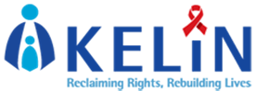
Your Ref: TBA Our Ref: WPR/KELIN/14 Date: 11 August, 2014
Dear Friends & Colleagues,

RE: APPOINTMENT AS THE ALTERNATE BOARD MEMBER OF THE DEVELOPING COUNTRIES NGO DELGATION TO THE GLOBAL FUND BOARD

Greetings from KELIN, a human rights NGO working to protect and promote HIV-related human rights in Kenya. We do this by; providing legal services and support, training professionals on human rights, engaging in advocacy campaigns that promote awareness of human rights issues, conducting research and influencing policy that promotes evidence-based change.

I am delighted to share with you news that I have been appointed as the Alternate Board Member for the Developing Countries NGO Delegation to the Global Fund Board. The Delegation is one of the 28 member constituencies that make up the Global Fund Board. Its mission is to influence policies and practices so that they are continually responsive to the needs of those affected by AIDS, TB and Malaria in the Global South.

This exciting expansion of my role within the Delegation will enable me together with colleagues who work in the Delegation to better promote our objectives, and effectively bring the voices of developing countries’ civil society constituencies to the governance and decision making structures of the Global To Fight AIDS Tuberculosis & Malaria (GFATM). We should also effectively communicate the discussions and decisions made by the GFATM Board to civil society constituencies in developing countries. This will be done in a manner that takes into account the relevant human rights principles.

I look forward to partnering, collaborating and working with you on areas of mutual interest as they relate to the work of the (GFTAM) Thanking you for your continued support.

Yours Faithfully,
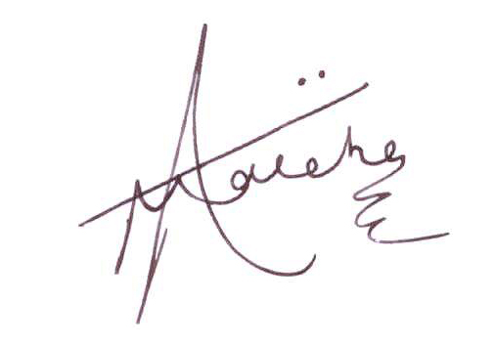
Allan Maleche
Executive Director

